VISVESVARAYA TECHNOLOGICAL UNIVERSITY


JNANA SANGAMA, BELAGAVI– 590018, KARNATAKA, INDIA
A MINI PROJECT REPORT
on
“ANNAMITRA”
Left Over Food Sharing App
Submitted in partial fulfilment of the requirements for the award of
BACHELOR OF ENGINEERING
in
ARTIFICIAL INTELLIGENCE & MACHINE LEARNING
Submitted By
Name USN
POORVIKA A S 4VP23AI032
RAKSHITHA PRABHU 4VP23AI038
SHRADDHA S J 4VP23AI046
YASHASVI A RAI 4VP23AI063
Under the Guidance of
Prof. Nidhishree M P

Assistant Professor

DEPARTMENT OF ARTIFICIAL INTELLIGENCE & MACHINE LEARNING
VIVEKANANDA COLLEGE OF ENGINEERING & TECHNOLOGY
[A Unit of Vivekananda Vidyavardhaka Sangha Puttur (R)]
Affiliated to Visvesvaraya Technological University and Approved by AICTE New Delhi & Govt., of Karnataka
Nehru Nagar, Puttur - 574 203, DK, Karnataka, India.
NOVEMBER 2025
VIVEKANANDA COLLEGE OF ENGINEERING & TECHNOLOGY
[A Unit of Vivekananda VidyavardhakaSangha Puttur (R)]
Affiliated to Visvesvaraya Technological University and Approved by AICTE New Delhi & Govt. of Karnataka
Nehru Nagar, Puttur - 574203, DK, Karnataka, India

DEPARTMENT OF ARTIFICIAL ENGINEERING & MACHINE LEARNING

CERTIFICATE
Certified that the mini project work entitled “ANNAMITRA” Left Over Food Sharing App is carried out by Ms. Poorvika A S, Ms. Rakshitha Prabhu , Ms. Shraddha S J, Ms. Yashasvi A Rai bearing USNs 4VP23AI032, 4VP23AI038, 4VP23AI046 and 4VP23AI063 respectively bonafide students of Vivekananda College of Engineering & Technology, Puttur in partial fulfilment for the award of Bachelor of Engineering in Artificial Intelligence & Machine Learning of the Visvesvaraya Technological University, Belagavi during the year 2025-26. It is certified that all corrections/suggestions indicated during Internal Assessment have been incorporated in the report deposited in the departmental library.
The project report has been approved as it satisfies the academic requirements in respect of Project work prescribed for the said Degree.

Signature of the Guide Signature of the HOD Signature of the Principal
Prof. Nidhishree M P Prof. Abhishek Kumar K Dr. Mahesh Prasanna K

EXTERNAL VIVA
Name of the Examiners Signature with date

1…………………………….............. ....................................

2…………………………….............. ....................................

DECLARATION

We, Ms. Poorvika A S (4VP23AI032), Ms. Rakshitha Prabhu (4VP23AI038), Ms. Shraddha S J (4VP23AI046), Ms. Yashasvi A Rai (4VP21AI063) students of B.E. 5th Semester in Artificial Intelligence & Machine Learning, Vivekananda College of Engineering & Technology, Puttur, hereby declare that the project work entitled “Annamitra-LeftOver Food Sharing App” has been carried out by us at VCET, Puttur, under the guidance of Prof. Nidhishree M .P, Assistant Professor, Department of Artificial Intelligence & Machine Learning, Vivekananda College of Engineering & Technology, Puttur, and submitted in partial fulfillment of the requirements for the award of degree in Bachelor of Engineering in Artificial Intelligence & Machine Learning by Visvesvaraya Technological University, Belagavi during the academic year 2025-2026.

Name of the students | USN | Signature with date
Poorvika A S | 4VP23AI032
Rakshitha Prabhu | 4VP23AI038
Shraddha S J | 4VP23AI046
Yashasvi A Rai | 4VP23AI063

Date:
Place: Puttur

ACKNOWLEDGEMENT

We take this opportunity to express our deep heartfelt gratitude to all those people who have helped us in the successful completion of the project.

First and foremost, we would like to express our sincere gratitude to our guide, Prof. Nidhishree M P for providing excellent guidance, encouragement and inspiration throughout the project work. Without her invaluable guidance, this work would never have been a successful one.

We would like to express our sincere gratitude towards our project coordinator, Prof. Ajay Shastry C G, Assistant Professor, Department of Artificial Intelligence & Machine Learning, for her guidance and inspiration.

We would like to express our sincere gratitude to Head of the Department, Department of Artificial Intelligence & Machine Learning, Prof. Abhishek Kumar K, for his guidance and inspiration.
We would like to thank our Principal, Dr. Mahesh Prasanna K for providing all the facilities and a proper environment to work in the college campus.

We would like to thank our management for providing the necessary infrastructure to carry out the project work

We are thankful to all the teaching and non-teaching staff members of Artificial Intelligence & Machine Learning Department for their help and needed support rendered throughout the project.

ABSTRACT

Excessive food wastage is one of the major problems our society is facing in today's world. Every day, huge amounts of food are wasted coming from homes, restaurants, hotels, and functions. Many poor and needy people find it difficult to get even one proper meal. This imbalance in the system occurs mainly because there is no proper way to connect food donors with people who are in need of food. The project will aim to reduce food wastage and help needy people through the use of technology in an easy, useful way. The project “ANNAMITRA – Left Over Food Sharing App” is a mobile-based application meant for creating a bridge between food donors and receivers. Donors can be individuals, restaurants, or event organizers who have surplus food; receivers can be NGOs or people in need. The main objective of this app will be to make food sharing quick, easy, and safe. This application will utilize AI and ML techniques in food-type identification, classifying it into categories like Veg or Non-Veg by using the Convolutional Neural Network model. The donor uploads the image of leftover food, and the system will predict the category of leftover food. The details such as food type, quantity, and location are stored in the SQLite database by using Flask Framework as the backend. It will use location services to find nearby receivers with the help of the Haversine formula, which will make the pickup of food easier and faster. It ensures the security of login for users while allowing access to only verified donors and receivers. This enhances safety and trust in food sharing. The app is user-friendly, and anyone who owns a smartphone connected to the internet can use it. Through this project, food wastage will be reduced, and simultaneously, social welfare and people who are hungry will be aided. It also spreads awareness about the importance of sharing food rather than wasting it. In the future, this system can be improved by adding more features like delivery partner integration, real-time notifications, NGO network expansion, and demand prediction using AI. As a whole, ANNAMITRA is a small step toward building a responsible and caring society with the help of technology

TABLE OF CONTENTS

Title | Page No.
List of Figures | I
List of Tables | II
List of Abbreviations | III
CHAPTER 1 INTRODUCTION | 01
1.1 Introduction to the project | 01
1.2 Existing System | 01
1.3 Proposed System | 02
1.4 Scope of the Project | 03
1.5 Objectives of the Project | 03
1.6 Organization of The Report | 04
CHAPTER 2 LITERATURE SURVEY | 06
2.1 Summary of Literature Survey | 22
CHAPTER 3 ANALYSIS AND REQUIREMENT SPECIFICATION | 26
3.1 Introduction | 26
3.2 Existing System | 26
3.3 Non-Functional Requirements | 27
3.4 User Interface Requirements | 28
3.5 Software Requirements | 29
3.5.1 TensorFlow | 29
3.5.2 Keras | 30
3.5.3 OpenCV | 30
3.5.4 Numpy | 31
3.5.5 Streamlit | 32
3.6 Hardware Requirements | 33
CHAPTER 4 SYSTEM DESIGN | 35
4.1 Introduction | 35
  - Overview of the Proposed System 35
  - Block Diagram 35
CHAPTER 5 SYSTEM IMPLEMENTATION 38
  - Introduction 38
  - Algorithm Used 38
    - Convolutional Neural Network (CNN) 38
    - Image Pre-processing and Augmentation 39
    - Mel Spectrogram Feature Extraction 40
    - Adam Optimizer 41
    - Class Label Prediction 41
  - Implementation 41
    - About Dataset 42
    - Workflow 42
CHAPTER 6 RESULT AND DISCUSSIONS 45
  - Snapshots 45
CHAPTER 7 CONCLUSION AND SCOPE FOR 57
FUTURE ENHANCEMENT
  - Conclusion 57
  - Scope for future enhancement 57
REFERENCES 59
PERSONAL PROFILE 62

LIST OF FIGURES

Figure No. | Title | Page No.
4.1 | Block Diagram of Proposed System | 36
6.1 | GUI Window for Annamitra-LeftOver Food Sharing App | 45
6.2 | Displays serve food for veg | 46
6.3 | Displays serve food for nonveg | 47
6.4 | Displays search food for veg | 48
6.5 | Displays search food for nonveg | 49

LIST OF TABLES

Table No. | Title | Page No.
2.1 | Summary of Literature Survey | 22

LIST OF ABBREVIATIONS

Abbreviation Description

AI | Artificial Intelligence
ML | Machine Learning
CNN | Convolutional Neural Network
ReLU | Rectified Linear Unit
SQLite | Structured Query Language Lite
Flask | Python Web Framework
HTML | HyperText Markup Language
CSS | Cascading Style Sheets
API | Application-Programming Interface
OSM | OpenStreetMap

CHAPTER 1

INTRODUCTION

Introduction to the Project
The world today faces a serious issue: too much good food is wasted while many people are still hungry. Every year, massive amounts of food are thrown away. This costs a lot of money and creates a big problem for the environment. The simple old-fashioned ways of donating leftover food are usually too slow and the food often spoils before it reaches anyone.
The ANNAMITRA project which we call the "Left Over Food Sharing App" is a smart tech-based answer to this problem. It is designed as one easy-to-use digital platform that quickly connects people who have extra food (like restaurants and homes) with people who need it (like charities or individuals).
The most important part of ANNAMITRA is the use of Artificial Intelligence (AI) and Machine Learning (ML), specifically a Convolutional Neural Network (CNN). This smart technology does two key jobs:
Dietary Classification: When a donor uploads a picture of the food, the CNN instantly analyzes the image. It figures out the food type and most importantly if it is Vegetarian (Veg) or Non-Vegetarian (Non-Veg). This makes sure that recipients receive food that matches their dietary needs right away.
Fastest Match Finding: The system takes the food details and the donor's exact location. It then uses a math rule called the Haversine formula to quickly calculate the shortest distance to all nearby receivers. This fast, planned matching ensures the extra food gets to the closest person quickly, keeping it fresh and avoiding waste. ANNAMITRA uses digital tools and smart planning to turn an unorganized effort into a strong, reliable system that helps the community, reduces waste, and supports people in need.
1.2 Existing System
In the current system food donation is mostly done through manual communication or informal methods. People who want to donate leftover food usually contact nearby NGOs, orphanages or volunteers through phone calls or social media. These traditional methods are slow and unorganized. Many times, food donors are not aware of who actually needs food in their area and as a result good food often goes to waste.
There are a few mobile apps and organizations that try to connect donors and receivers, but they are limited in features. Most of these platforms do not use Artificial Intelligence (AI) or location-based systems to make the process faster. In such systems, users have to manually enter food details, location, and type, which takes time. There is also no way to automatically classify food as vegetarian or non-vegetarian. Because of this the chances of mismatched or delayed donations are high.
Moreover, existing systems do not focus on real-time tracking or quick matching between donors and receivers. The lack of smart features like automated classification, distance calculation, and notifications makes them less efficient. This leads to slow response time, and often, the food becomes unusable by the time it reaches those in need.
Overall, the current food donation process is less effective because it lacks automation, proper coordination, and real-time connection between donors and receivers. This is why a smarter AI-based system like ANNAMITRA is needed to make the process easier, faster, and more reliable. In the current system food donation is mostly done through manual communication or informal methods. People who want to donate leftover food usually contact nearby NGOs, orphanages or volunteers through phone calls or social media. These traditional methods are slow and unorganized. Many times, food donors are not aware of who actually needs food in their area and as a result good food often goes to waste.
There are a few mobile apps and organizations that try to connect donors and receivers, but they are limited in features. Most of these platforms do not use Artificial Intelligence (AI) or location-based systems to make the process faster. In such systems, users have to manually enter food details, location, and type, which takes time. There is also no way to automatically classify food as vegetarian or non-vegetarian. Because of this the chances of mismatched or delayed donations are high.
Moreover, existing systems do not focus on real-time tracking or quick matching between donors and receivers. The lack of smart features like automated classification, distance calculation, and notifications makes them less efficient. This leads to slow response time, and often, the food becomes unusable by the time it reaches those in need. Overall, the current food donation process is less effective because it lacks automation, proper coordination, and real-time connection between donors and receivers. This is why a smarter AI-based system like ANNAMITRA is needed to make the process easier, faster, and more reliable.

  - Proposed System

The ANNAMITRA – Left Over Food Sharing App is designed to solve the problems faced in the existing food donation process by using modern technology. It provides a smart, automated, and easy-to-use digital platform that connects food donors and receivers directly. The system uses Artificial Intelligence (AI), Machine Learning (ML), and location services to make food sharing faster more accurate, and reliable.
In this system, donors can upload details of the food they want to share, such as food name, quantity, and location, along with a picture. When the image is uploaded the app uses a Convolutional Neural Network (CNN) model to analyze the photo and automatically identify the food type. It also classifies the food as Vegetarian or Non-Vegetarian. This automatic categorization helps receivers quickly decide what kind of food is available before requesting it.
The system also uses live location tracking with the help of GeoPy and OpenStreetMap API. This allows the application to show nearby food donations based on the receiver’s location. The distance between the donor and receiver is calculated using the Haversine formula which ensures that the nearest available food is shown first. This helps in reducing delivery time and prevents food from getting spoiled.

All data such as user details, food information, and locations are stored securely in a SQLite database. The backend of the system is developed using Flask which handles user authentication, data storage, and communication between users and the AI model. The system ensures that all user information and food details are safely managed. Compared to the existing manual process, this system is faster, more accurate, and fully automated. It reduces human effort and ensures that leftover food reaches people in need before it goes to waste. Overall, ANNAMITRA creates a smart, efficient, and community-driven platform for responsible food sharing.

  - Scope of the Project
This project has a wide scope as it aims to reduce food wastage and connect donors with people who need food in a simple and organized way. It can be used by individuals, restaurants, hotels, event organizers, and NGOs to share leftover food through a web or mobile platform. The system uses Artificial Intelligence to identify food type and category and location tracking to show nearby donations which makes the process quick and efficient. All user and food details are securely stored in a database ensuring smooth data management. In the future the app can be expanded to include delivery partners, volunteer groups, and automatic pickup scheduling to make food sharing even easier. It can also generate useful reports showing the total food shared and the number of people helped. By reducing food waste the project supports sustainable living and encourages social responsibility. Overall, ANNAMITRA has the potential to grow into a complete digital system that helps create a hunger-free and eco-friendly society.

  - Organization of the Report

This report is divided into several chapters, each explaining a different part of the project in a simple and logical order. It helps the reader clearly understand the purpose of the project the process followed during its development and the final outcomes achieved through the proposed system.
Chapter 1 introduces the project and gives an overall idea about the ANNAMITRA – Left Over Food Sharing App. It explains the growing problem of food wastage, the main goals of the project and how Artificial Intelligence and Machine Learning are used to make the food-sharing process smarter and faster. The chapter also highlights the motivation, objectives, and scope of the project.
Chapter 2 provides the literature survey explaining existing systems and related research work. It reviews different methods and tools that are currently used for food donation and classification. This chapter also compares traditional systems with the proposed ANNAMITRA system and shows how AI-based automation and location tracking make it more efficient.
Chapter 3 focuses on the system design and architecture. It explains the various modules, including user management, food detection using CNN, and location-based matching. The chapter also includes diagrams like data flow diagrams and use case diagrams to visually describe how the system works internally.
Chapter 4 discusses the system implementation, covering both the software and hardware requirements. It describes how the backend was developed using Flask how the AI model was trained using TensorFlow and Keras and how different components were integrated to form a complete working system. Screenshots and output results of the working application are also presented in this chapter.
Chapter 5 presents the results, advantages, and applications of the system. It summarizes the key achievements of the ANNAMITRA app such as accurate food classification, easy donation process, and real-time food tracking. This chapter also discusses the project’s benefits, future scope, and concludes by emphasizing how the system contributes to reducing food wastage and helping people in need.
The References section lists all the books, research papers, websites, and online materials that were used while developing and studying the project

CHAPTER 2

LITERATURE SURVEY
Salah Uddin and Fozlay Rabby Ansary [1] wrote an article titled, "Share-a-Meal: A Mobile App-based Food Sharing System," which describe a very innovative technical solution to a growing challenge of food waste. They referred to the amount of food wasted each year, that is still in safe to eat, is staggering, and the economic and ecological impact of food waste is a significant concern. They proposed a mobile system based on the Internet of Things (IoT) that connects consumers of extra food waste to consumers that need food. The proposed system consists of a mobile food sharing software application, cloud server, and smart food collection box that has weight and temperature sensors and a cooling system. It includes a secure access PIN to collect the food. The system is straightforward. The donor enters the extra (safe, and healthy) food they have, and at the same time, a real-time notification is sent to the recipient of available surplus food, indicating to the recipient they can pick up food from the food collection securely. They reported the system facilitated a food-sharing process that was more reliable, quicker, and safer. They claimed they had more trust as they received feedback through the app. Internet access and smartphone are required.

Priya Tushar Mohod et al [2] The article "A Mobile Application to Facilitate Meal Box Sharing in Corporate Environments Using Cloud Infrastructure proposed and published in 2024 in Electronics, introduces a mobile-based system to reduce food waste that occurs in workplace settings. The authors acknowledge that while digital food sharing applications exist (i.e. OLIO and Too Good to Go), they are mainly focused on households and communities, and not directly on the surplus or unwanted food in corporate environments. The app described in this paper uses cloud-enabling technologies to allow a workplace to share homemade, unspoiled dinners with coworkers. The front-end was designed in the Flutter framework, back-end work was done in Spring Boot, and MySQL was used for database administration, while AWS cloud capabilities were used to safely store and access images and other information, while keeping safety in mind. The app included supplier and consumer roles to post and search for meals, verify corporate email addresses for safety, logging in using an OTP, and in-app communication

using Firebase. The paper discusses a study using a user evaluation from 100 corporate participants.

The manuscript published in the British Food Journal presents a systematic literature review of “Mobile apps for reducing food waste at different levels of the supply chain”. The authors identify a main issue—is that in spite of the vast scale of global food waste and loss, we do not know much about apps, their impact reduction, food waste; their impact on food poverty; and what level of supply chain they are undertaken. To remedy of this, the authors apply a three-part methodology (planning, conducting, and reporting), that is structured, based on protocols of review of literature: a search of academic databases for relevant keywords and phrases (i.e., "mobile app", "food waste" etc.), filter, review, select articles published between 2007 - 2022, and synthesis findings regarding areas of study, type of impact and supply chain (Proposed Solution / Methodology). The authors found that the review revealed that most studies focused on consumption and procurement levels of the supply chain, many app were undertaken in developed countries, and most of the themes discussed were around innovation management, platform performance/acceptance and redistribution models. The authors acknowledge some limitations including, many studies were qualitative.

Arfandi Andres et al. [4] In a paper titled "Sharing Food with Food LifeSavr Smartphone App" presented at the 2022 International Conference on Artificial Intelligence and Smart Energy (ICAIS 2022), the authors summarize an innovative approach to solving the current issue of edible food waste while feeding hungry people. The introduction of the paper explains the similar problem of food waste simultaneously taking place at events, restaurants, etc., with lots of people struggling with hunger. The authors created Food LifeSavr - a smartphone app that relieves the responsibility of sharing food, and organizes potential donors, courier, and food recipients. The online process of development refers to user-case and class diagrams of the system design. The system design to an organized food-listing system sets forth modules for donor registration for food listing, a courier to deliver the donated food, real-time tracking of food delivery, and visual documentation with photos to limit dishonesty in the process. The application includes a donor forum section for donor-to-donor communications to build community and transparency. The study findings concluded that while the platform expedited the donation process to be able to empower donors to give to food sharing groups with confidence, the system involved accountability through real-time delivery tracking.

Christina Varghese et.al [5] The article "SeVa: A Food Donation App for Smart Living" presents a mobile-based system focused on reducing food waste while simultaneously addressing the state of hunger through the redistribution of food. The authors highlight the issue of large quantities of foods that are safe to consume being wasted on a daily basis by restaurants, events and grocery stores, while many individuals continue to experience food insecurity - A problem that has been worsened by the COVID-19 pandemic. In response to this, the authors proposed the SeVa app, which acts as an intermediary tool to connect donors to recipients, seamlessly providing listings with excess surplus food in real time on their smartphone application. The design of the app utilized principles of human-computer interaction, integrating IoT, to allow users to input information about food category, quantity, expiration date and freshness level; enjoyers would search for available food items, while in close vicinity. In addition to displaying physically safe and edible food to a user, the app accounts for geo and time-based factors to ensure food safety and relevance. Findings from a user-based evaluation of the app, indicated the application was positively received and considered simple, effective, and useful in sustainable food sharing. However, the authors recognize some limitations in their study as of stage of implementation to prototype and testing with just a small sample.

Miss Neha Dipak Shinde et.al [6] The article "Designing a Mobile Application for Food Wastage Reduction" in the journal of Emerging Technologies and Innovative Research (JETIR), Vol. 8, Issue 6, June 2021, proposes a food wastage prevention application for Android as a subsequent step in solving the problem. Simplifying the donation of surplus food to the neediest is another key objective of the project. As per the authors' observation, there are a lot of scraps and parts of food that are still suitable for consumption but are discarded from homes, restaurants, and parties every day, just because the process of food donation is not properly systematized. In response to the lack of timely action, the authors have creatively come up with the concept of an app that would enable donors to register, log in, and furnish the details of the food that is available. Administrator verifies this data. Local agents get the data by the administrator, and they after meeting the donors take the food from them and deliver it to the homeless shelters or any other place where it is needed. The method employs various modules such as login and registration, notifications, donor management, receiver details, and admin control, all of which are written in Java and XML on the Android Studio platform. The system is a design that not only makes the donation process easier and safer but also gives access to the donors and the recipients. Here, the app is a very handy tool in the redistribution of food and at the same time, it can be regarded as an influential means through which the social welfare can be elevated by lessening food wastage and extending help to the hunger relief programs. Though the research points out, on the other hand, that there are certain disadvantages such as the only platform the app can run is android, the closeness of the donors and receivers is a factor on which the app's operation is dependent, and if the app wants to be easily scalable, then there is a need for GPS, based automation. Various performance attributes such as availability, response time, and user participation in different sections were used for the evaluation. The authors stated that the application they developed is a feasible way to solve the problem of food wastage. At the same time, it is a great relief to the charitable organizations, and a step towards the enhancement of environmental sustainability. Their idea for the next stage of the features is the addition of such things as barcode or OCR scanning for automatic reading of food expiry dates and also by linking QR codes for ease of tracking and donation chain transparency.

K. N. Naveen Kumar et.al [7] The paper titled "Development of Leftover Food Management System Using Efficient Hunger Search Techniques" published at IEEE MysuruCon in 2021, revolves around the idea of resolving the paradox of food wastage happening simultaneously with hunger. The authors mention that a large amount of food that is still edible is being thrown away from the likes of houses, restaurants, and parties due to the lack of proper coordination between the donators and the receivers. To solve this problem, they come up with an idea of a mobile and web-based platform which utilizes a new "hunger search" algorithm to find donors to recipients in the nearest neighborhood thereby ensuring that the food distribution is not only rapid but also optimized. As a result, the prototype outputs show that the platform enhances the matching precision, leads to the decrease of leftover food, and promotes the exploitation of surplus resources in a more effective manner. However, the research indicates that there are some disadvantages such as a limited scale of deployment, the necessity for additional manual data entry, and the need for more stakeholders to be involved. The main criteria for identifying the system performance were matching efficiency, response time, and user feedback. The authors concluded the paper by stating that their system is a feasible and scalable solution to the problem of leftover food and proposing as the next steps the integration of real-time data, larger testing areas, and cooperation with NGOs and food organizations for increasing the effect.

Raktim Raihan Prova et.al [8] The paper, "A Web and Mobile-Based Approach to Redistribute Consumable Food Waste" (2021), IEEE ICCCNT, comprises “Needy Serve,” a web and mobile platform, to decrease food waste by connecting donors, volunteers, and recipients. The authors recognize that food wastage is not caused by a lack of food but is due to inefficient redistribution systems. Their solution allows donors to put up the surplus food, volunteers to pick it up and deliver it, and recipients to get it through the app, with an option mobile balance donations to cover the logistics costs. Apart from it, the testing with 43 users revealed a high acceptance level of the app-85% for functionality, 75% for navigation, and 73% for design-thus, indicating strong usability. Among the limitations of the research are small-scale testing, dependence on volunteers, and high mobile transaction fees. The evaluation was mainly centered on user acceptance, interface usability, and reliability. The paper findings show that “Needy Serve” is a powerful instrument in food waste reduction and providing help to the needy, and they have plans to upgrade the app for scaling, UI improvement, and expanding beyond food redistribution.

Vahid Jafari-Sadeghi et.al [9] article "Exploring the Impact of Digital Transformation on Technology Entrepreneurship and Technological Market Expansion" published in the Journal of Business Research (2021) investigates the effect of digital transformation on technological entrepreneurship and market expansion. The authors point out that the relationship between digital adoption and the generation of entrepreneurial value is still very unclear. The paper links technology readiness, digital exploration, and exploitation with entrepreneurship outcomes through the means of data from 28 European countries and structural equation modeling. The results signify that technology readiness has a good impact on both exploration and exploitation which finally leads to innovation and market expansion. The research is dependent on and limited by cross-sectional data and may be of limited relevance to emerging regions. The study was based on a variety of indicators such as ICT investment, digital innovation, and new venture activity. Besides suggesting future research in emerging countries with longitudinal data for a better understanding, the article concludes with a statement that digital transformation is the driver of entrepreneurship if firms can manage exploration and exploitation concurrently in an effective manner.

John Harvey et.al [10] The paper "Food Sharing, Redistribution, and Waste Reduction via Mobile Applications: A Social Network Analysis" published in Industrial Marketing Management (2020) argue that apart from reducing food waste, mobile apps like OLIO are also very instrumental in reshaping food redistribution networks. The authors point out that interactions between users in the real world are still mostly hypothetical, even though digital platforms may facilitate contact between donors and recipients. To understand sharing dynamics in the digital world, they conducted a social network analysis of 54,913 food-sharing transactions between 9,054 people over ten months. Conventional reciprocity theories cannot account for digital sharing behavior as actors rarely co-occur, organizations are usually at the exchange intermediaries, and consumers are mostly either givers or recipients. Moreover, the research only looks at one app and one country, does not have demographic data, and cannot verify offline behavior. In addition to these, transaction frequency, user connectivity, and network centrality were among the metrics used in the study.The paper concludes that mobile applications are a major factor in the transition of food distribution networks, but understanding user motives and social dynamics will need more research. It thus suggests that subsequent investigations should be conducted in other platforms and locations.

2.1 Summary of Literature Survey
The literature survey in Table 2.1 examines mobile and AI-based solutions for cutting down on food waste. These studies focus on connecting donors and receivers through intelligent, location-based platforms, though issues of scalability and automation remain.
Table 2.1: Summary of Literature Survey

Author | Title | Features | Pros | Cons
Uddin, M. S., & Ansary, F. R. (2025) | Share-a-Meal: A Mobile App-based Food Sharing System | App-based food sharing; connects donors & receivers; AI-based categorization | Reduces noise; helps with visual clarity; ideal for diverse conditions | Limited scalability; depends on active users
Mohod, P. T., et al. (2024) | Meal Box Sharing in Corporate Environments Using Cloud Infrastructure | Cloud-based app for meal redistribution in workplaces | Secure cloud integration; promotes zero waste at workplace | Focused on corporate setting only

 | Hong, J., Jaegler, A., & Gergaud, O. (2023) | Mobile Apps to Reduce Food Waste in Supply Chains: A Review |  | Survey of various mobile food waste reduction apps |  | Provides comparative insights; identifies success factors |  | Lacks implementation of a specific model
 | Andres, A., et al. (2022) | Sharing Food with Goodliffes’ve Smartphone App |  | Real-time food donation with AI-based alerts |  | Simple interface; effective food tracking |  | Limited AI integration; no predictive model
 | Varghese, C., Pathak, D., & Varde, A. S. (2021) | SEVA: A Food Donation App for Smart Living |  | Mobile app linking donors and NGOs; geolocation-based |  | Efficient matching; easy-to-use interface |  | No ML-based optimization; manual matching
 | Shinde, N. D., & Patil, A. (2021) | Designing a Mobile Application for Food Wastage Reduction |  | App for restaurants to list surplus food |  | Simple, low-cost approach; focuses on restaurant sector |  | Lacks automation and AI components
 | Nukala, S. S., et al. (2021) | Leftover Food Management System Using Efficient Hunger Search Techniques |  | AI-based hunger search and food management |  | Uses ML algorithms for efficient distribution |  | Complex to implement; requires large dataset
 | Prove, R. R., et al. (2021) | Web and Mobile-Based Approach to Redistribute Consumable Food Waste |  | Combines web & mobile access; cloud storage |  | Broader accessibility; data backup |  | Higher maintenance and latency
 | Mazzuchelli, A., et al. (2020) | Key Factors for a Successful Food Sharing Platform |  | Study on factors affecting food-sharing success |  | Identifies design & user trust factors |  | Theoretical; lacks prototype implementation
Harvey, J., et al. (2019) |  |  | Food Sharing and Waste Reduction via Mobile Apps: A Social Network Analysis |  | Social network analysis of sharing apps |  | Highlights community dynamics & influence | No technical or algorithmic development

CHAPTER 3

ANALYSIS AND REQUIREMENT SPECIFICATION

Introduction
In today’s world, one of the biggest problems we see around us is food wastage. Every day, tons of food go to waste in homes, restaurants, and hotels, while many people are still struggling to get even one proper meal. This is something that really made us think about how technology could help make a change.
Our project “ANNAMITRA – Leftover Food Sharing App” is designed to bridge this gap between food donors and people who need food. The main idea is simple — instead of letting surplus food go to waste, why not connect the people who have it with those who can use it? With this thought, we developed an application that uses Artificial Intelligence (AI) and Machine Learning (ML) to automatically identify and classify the donated food, and then match it with nearby NGOs or receivers.
This chapter explains the complete analysis and requirements of our project. It discusses what problems exist in the current situation, how our system overcomes those issues, and what kind of software and hardware setup is required to make it work effectively. The analysis forms the base for building a well-structured and reliable system.

Existing System
In the current scenario, there is no proper platform that connects food donors with receivers in an organized way. Most of the time, food donation happens manually — people call NGOs, message them, or share details on social media. This method takes time and sometimes the food gets spoiled before it can be collected.
Although there are some international food-sharing apps, they are either limited to certain areas or designed for commercial use. They don’t focus on the Indian context or local needs, and many of them require constant internet access and technical knowledge. Moreover, they don’t have AI-based features like automatic food classification or live location tracking.
In short, the existing systems are not efficient enough to handle real-time food donations, especially in smaller towns or rural areas. There is a clear need for a simple, smart, and reliable application that connects donors and receivers quickly, without complicated steps. Our project ANNAMITRA tries to fill this gap by using modern technologies like AI and Flask to make the food-sharing process smooth and automatic.

Non-Functional Requirements
Non-functional requirements describe how well the system performs rather than what it does. These qualities ensure the system is efficient, secure, and user-friendly.
- Performance:
The system should process uploaded images and provide results within a few seconds. It should not lag even if several users use the app at the same time.
- Reliability:
The application should give consistent and accurate results every time. All user and donation data must be stored safely in the database.
- Usability:
Since the app is meant for all kinds of users, including those who are not tech-savvy, it should be easy to use with clear instructions and simple navigation.
- Scalability:
The system should be able to handle more users and more food categories in the future without slowing down.
- Security:
The application should protect user information and login details using encryption. Flask-Bcrypt is used to hash passwords and keep them safe.
- Maintainability:
The code and design should be easy to update whenever needed, for example, when adding new features or fixing bugs.
These qualities make sure the system runs smoothly, safely, and remains useful for a long time.

3.4.User Interface Requirements
The user interface (UI) plays a major role in how comfortable and simple the application feels to users. Our goal was to design a UI that is clean, straightforward, and responsive.
The app allows two types of users — donors and receivers (or NGOs). Donors can sign up, log in, and upload an image of leftover food along with some basic details such as the type of food, quantity, and location. The system then predicts whether the food is vegetarian or non-vegetarian using the AI model. On the other hand, receivers or NGOs can log in and see the available food donations near them, along with the pickup location shown on a map.
The interface includes:
- A simple login and signup page
- A donation page for uploading food images and entering details
- A results page showing the predicted food category
- A search page for receivers to find available food
- Map integration for live donor locations
The overall design is built using Flask with HTML templates and integrated with Python code. The layout is kept clean, with minimal text and clear buttons, so users can easily understand how to use it without needing technical knowledge.
3.5 Software Requirements
The software setup is chosen to make sure that both the AI model and the web app work together smoothly.
                - Operating System: Windows 10/11, Linux, or macOS
                - Programming Language: Python 3.8 or above
                - Framework: Flask for backend and web interface
- Machine Learning Libraries: TensorFlow and Keras for training and running the CNN model
- Image Processing Library: OpenCV for capturing, resizing, and processing food images
- Database: SQLite for storing user and donation details
- Security Library: Flask-Bcrypt for password encryption
- Additional Tools: SQLAlchemy for database management and Visual Studio Code for development
All these tools and libraries are open-source, making the project cost-effective and easy to maintain.

3.5.1 TensorFlow
TensorFlow is an open-source deep learning library developed by Google. It is used for training the Convolutional Neural Network (CNN) that identifies food images. TensorFlow helps perform complex mathematical operations quickly and allows the model to give accurate results in less time.

3.5.2 Keras
Keras is built on top of TensorFlow and makes model building much easier. It provides simple functions to define layers, activation functions, and optimizers. We used Keras to train and fine-tune our CNN model that classifies the food into vegetarian or non-vegetarian.

3.5.3 OpenCV
OpenCV is used for image-related tasks such as reading, resizing, and enhancing food images before sending them to the model. It also helps in capturing live images directly through a webcam or mobile camera. This makes real-time food classification possible.
3.5.4 NumPy
NumPy is a Python library for numerical operations. It is used to handle image arrays, perform mathematical calculations, and make data compatible with TensorFlow and OpenCV. It basically helps the system process data faster and more efficiently

3.5.5 Flask / Streamlit
The Flask framework is used to create the web-based application and manage the backend process. It connects all parts of the system — from user login to model prediction and database operations. For demonstration purposes, Streamlit can also be used to create a simple dashboard that shows predictions in a clean and interactive way.

3.6 Hardware Requirements
To make sure the app runs smoothly, the following hardware setup is recommended:
The app requires at least an Intel Core i3 processor, 4 GB RAM, and 2 GB of free storage to run.
For optimal performance, a system with an Intel Core i5 or higher, 8 GB+ RAM, and a 500 GB HDD/SSD is recommended.
While it can function with an integrated GPU and a 720p webcam, using an NVIDIA GPU and an HD camera or IP camera ensures smoother, faster image processing.
A stable internet connection is essential, with high-speed Wi-Fi preferred, and the app should run on Windows 10 or Linux, ideally the latest version.
The configuration ensures the system can handle real-time food image classification and data storage without any delay or crash.

- .
CHAPTER 4

Introduction

SYSTEM DESIGN
The ultimate purpose of the system designANNAMITRA-Leftover Food Sharing Application is to develop a quality, smart, and modular system that makes food redistribution easier and more efficient. So, the design of the overall structure was very harmonious in terms of the functionalities of each part, thus enabling a single online ecosystem to connect donors, recipients, and NGOs. Also, it is powered by A.I. technology. Giving away food can be completely automated and additionally, it may be enhanced by machine learning (ML) as well as the use of geo location-based services. Community adoption, through the implementation architecture, of the widely practice is highly scalable, secure, and real-time performative. The ANNAMITRA system's multi-layered architecture includes user interaction modules, backend logic, decision-making with AI, and cloud database integration. Obviously, they are each capable of working independently but can also communicate with each other through APIs and, thus, be able to operate smoothly even if they experience extreme traffic or network

Overview of the Proposed System

The designed system is an application both online and mobile-accessible that serves as a green link between food donors and recipients. This platform makes it possible for the ones having surplus food to openly share the most detailed information (what, how much, when it is going to be used, and where) and, thereby, relieves the receivers in locating the providers or placing orders according to their needs.
First of all, quality, location, and time factor are the three aspects against which ML and AI models are perfectly matched to facilitate fair and timely food redistribution.The app is also fitted with features such as instant notifications and location tracking that enable donation pick-up and drop-off to be planned easily and conveniently.

Main elements of the system include:
• User Module – It is the main entity for the performance of registration, login, and authentication of donors and receivers.

• Donation Module – The module, by facilitating donors to provide food details along with pictures and expiration date, is
• Search & Matching Module – The receiver's need for local food donation through searching, filtering, and sending requests is
• AI/ML Module – This module utilizes classification algorithms for the division of food into categories (Veg/Non-Veg) and facilitation best matching suggestions.
• Notification Module – Provides the users with the most up-to-date notifications concerning their orders, confirmations, and the progress of the pickups.
• Database Module – Aims at the secure maintenance of user profiles, food items, and transaction history in Firebase or SQLite.
• Location Services – Depend on the GeoPy and OpenStreetMap APIs for distance calculation and route planning.
The current system is designed to have the capacity to add future features such as the inclusion of delivery partners, a feedback system, and the back-end infrastructure scaling up to be able to handle more users. The use of AI makes sure that food supplies are distributed in an intelligent way and that the amount of wastage is also ​‍​‌‍​‍‌​‍​‌‍​‍‌reduced.

Block Diagram
A block diagram represents graphically a process in a system. It is used to illustrate the sequence of tasks that provide a clear visual overview of the process.
So here the flow diagram of System includes Data Collection, Pre-Processing, Feature Extraction, Classification, Disease Identification and User interface and Output.

.
CHAPTER 5

SYSTEM IMPLEMENTATION

Introduction
This design will be converted to a functional website in the implementation phase of the ANNAMITRA-Left Over Food Sharing App connecting food donors and receivers. This involves integrating the machine learning model with a user interface, database, and location features into one working system. The project applied a CNN for recognizing and categorizing food items with respect to uploaded images while the framework for the entire functionality was provided by Flask which handles user interaction and data flow. Users are allowed to register themselves, donate food, and search for donations available in their neighborhood. Using the trained CNN model the system automatically categorizes the food as Vegetarian or Non-Vegetarian while the Haversine formula is applied to calculate the shortest distance between donors and receivers. This will involve the creation of a dependable, accurate, user-friendly technological platform to help reduce food wastage.

Algorithm Used
The ANNAMITRA system integrates several algorithms and technologies in performing this food sharing with high accuracy and efficiency. Convolutional Neural Network forms the fundamental algorithm that is employed in recognizing the type of food through the images uploaded by the users. Along with CNN, many other supporting techniques are also employed, including image preprocessing, extraction of features, and optimization methods such as Adam Optimizer. The system calculates the geographic distance between users using the Haversine formula, which makes it easy to connect donors with receivers in a short time.

Convolutional Neural Network (CNN):
The core algorithm used for disease detection in this project is a Convolutional Neural Network (CNN), which is especially well-suited for analyzing image data. CNNs have become the standard approach for tasks such as categorizing images because they can automatically learn and extract patterns from images without manual feature engineering. In this project, the CNN takes input images of arecanut leaves—either healthy or affected by diseases like yellow leaf disease or spot disease—and predicts the correct class based on the patterns it learns during training.
The CNN processes images through a series of layers, each with a specific role. It begins with convolutional layers, which apply small filters across the image to detect simple features like edges and textures. These layers help the network identify the basic structure of the leaf. Next, activation layers (typically using the ReLU function) introduce non- linearity, enabling the model to learn more complex patterns beyond straight lines and shapes.
To reduce the amount of data and focus on the most important features, the network uses pooling layers usually max-pooling which down sample the image while keeping the most significant information. This not only speeds up computation but also enables the model to be more robust to slight changes in image position or lighting. In between, dropout layers may be included to randomly deactivate some neurons during training, which helps prevent the model from overfitting and improves generalization.
Once the image has been through several convolution operations and pooling stages, it reaches the fully connected layers, where all the extracted features are combined and interpreted. These layers act like a traditional neural network, learning to associate specific feature combinations with disease categories. Finally, the output layer produces the prediction telling whether the leaf is healthy or affected, and by which disease.
Through this structured learning process, the CNN gradually understands what visual indicators are present in different diseases, making it a powerful tool for real-time, accurate diagnosis of arecanut leaf diseases directly from images.

Image Pre-processing and Augmentation:
Image pre-processing is a crucial step in preparing the dataset for training a Convolutional Neural Network (CNN). It ensures that the input data fed into the network is consistent in terms of size, scale, and format, which helps improve both the efficiency and performance of the model. In this project, each input image undergoes several preprocessing steps to maintain uniformity and enhance model accuracy.
Firstly, all images are resized to a fixed dimension of 224x224 pixels. This resizing is necessary because CNN architectures typically require inputs of a consistent size, and using a standard resolution ensures compatibility with pre-trained models such as MobileNetV2, which was used in this project. Moreover, working with smaller, fixed-size images reduces the computational burden and speeds up the training process.
Next, the pixel values of the images are normalized by dividing each value by 255. This scales the pixel values from the original range of [0, 255] to a normalized range of [0, 1]. Normalization is essential for faster convergence during training and helps avoid issues caused by varying image brightness or lighting conditions. It also ensures that all input features contribute equally to the training process.
The images are also converted into an appropriate format, typically as NumPy arrays or
tensors, to be compatible with TensorFlow and other deep learning frameworks. This format conversion enables efficient batch processing and parallel computation during training and inference.
Although not explicitly implemented in the current codebase, data augmentation techniques such as random rotations, horizontal and vertical flipping, zooming, and brightness adjustments can also be incorporated during pre-processing. These techniques generate new, slightly altered versions of the existing images, effectively increasing the size of the dataset without requiring additional data collection. Data augmentation plays a critical role in enhancing the model’s generalization ability by exposing it to a wider variety of image variations, which helps reduce overfitting and improves performance on unseen data.
In summary, image pre-processing in this project involves resizing, normalization, and format conversion to ensure consistent and efficient input to the CNN. When combined with optional data augmentation strategies, these steps contribute significantly to the development of a more robust and accurate classification model.

Mel Spectrogram Feature Extraction:
Although this project currently focuses on image-based disease detection, there's potential to expand it in the future by incorporating audio-based diagnostics. For example, in some advanced farming setups, sensors can pick up audio signals related to plant health such as the sound of pests, changes in irrigation, or even subtle noises from equipment used in the field. In such cases, one powerful method for processing these sounds is the Mel Spectrogram.
A Mel Spectrogram is a way of turning audio into a kind of picture. It converts the sound signal into a visual format that shows how different frequencies (like pitches or tones) change over time. This is useful because it allows audio to be analyzed similarly to images, using the same techniques we use in computer vision like Convolutional Neural Networks (CNNs).
If audio data were to be included in this project in the future, the Mel Spectrogram could be used to extract meaningful patterns from sound, just like we currently do with leaf images. These patterns could then help in detecting issues such as pest activity or changes in the environment that might affect crop health. This approach opens up exciting possibilities for making the disease detection system even more intelligent and responsive
to various signals from the farm.

Adam Optimizer:
In this project, the Adam Optimizer is used during the training phase of the model to help it learn more effectively. Adam stands for Adaptive Moment Estimation and combines the strengths of two other well-known optimization techniques: AdaGrad, which handles sparse gradients well, and RMSProp, which works well in non-stationary environments. What makes Adam especially useful is that it automatically adjusts the learning rate for each parameter based on how much it's changing. This means the model can learn faster and more smoothly, without getting stuck or making unstable updates.
Adam is also computationally efficient, which makes it ideal for training deep learning models like CNNs. Because of its speed, reliability, and ability to handle noisy data or complex patterns, it has become one of the most widely used optimizers in the deep learning community and it's a great fit for our arecanut disease detection system.

Class Label Prediction:
Once the model has been successfully trained, it allows for making predictions on new images this is known as the inference phase. When an image of an arecanut leaf is given to the model, it processes the image and tries to identify which category it belongs to: healthy leaf, spot disease, or yellow leaf disease. At the final layer of the CNN, a softmax activation function is applied. This function turns the model’s raw output into a set of probabilities, showing how confident the model is about each class. The class with the highest probability is considered the model’s prediction. To determine which class that is, the np.argmax function is used it simply finds the index of the highest probability in the list. That index is then matched to a class name (like "Healthy" or "Spot Disease") using a predefined list called class_labels, making the result easy to understand for users. This process allows the system to give quick and accurate feedback on the condition of the arecanut leaf.

Implementation
This section outlines the development of a desktop application designed to detect and classify diseases in Arecanut leaves using a Convolutional Neural Network (CNN). The application aims to process input images of Arecanut leaves, identify whether the leaf is healthy or affected by diseases such as yellow leaf disease or spot disease, and provide
accurate predictions. By utilizing a pre-trained CNN model, the software preprocesses images, extracts relevant features, and classifies the leaf's condition. Additionally, the application includes a feature that provides users with disease-specific precautions and remedies. The system is designed to be user-friendly, allowing for easy interaction through a graphical interface, where users can upload images or capture them using device cameras. With real-time disease detection and actionable recommendations, this application provides a comprehensive solution for monitoring and managing Arecanut leaf health.

About Dataset
To develop an effective deep learning model for classifying arecanut leaf diseases, a balanced dataset was prepared comprising a total of 600 images. This dataset includes 200 images each of healthy leaves, yellow leaf diseased leaves, and spot diseased leaves. The images were taken from a range of arecanut plantations and verified manually to ensure quality and correct labeling. Each image captures the unique visual features of the respective condition under different lighting and angle variations. This well-curated dataset serves as the foundation for training a Convolutional Neural Network (CNN) model capable of accurately identifying and distinguishing between healthy and diseased leaves, contributing to early detection and preventive care in arecanut farming.

Workflow
Workflow refers to the sequence of steps or tasks involved in completing a process or achieving a specific outcome.
      - Upload Leaf Image: The system allows the user to upload an image of an arecanut leaf through a user-friendly interface. This feature also supports capturing real-time images using a device camera, external webcam, or IP webcam. Validation mechanisms ensure that the uploaded file is in the correct format (JPEG/PNG) and suitable for disease detection. It also checks the clarity and relevance of the image to avoid misclassification due to incorrect inputs. This step acts as the entry point for leaf image analysis, providing flexibility for both offline uploads and live camera input methods. The goal is to make the process simple and accessible for farmers, agricultural workers, or researchers with varying levels of technical skill.
      - Pre-process Image: Once the image is uploaded or captured, it undergoes several preprocessing steps including resizing to 224×224 pixels, normalizing pixel values,
and converting the image into a format suitable for model inference. These steps help in maintaining uniformity across all images regardless of where or how they are captured. Additionally, a green area detection technique is applied to verify whether the uploaded image contains an actual arecanut leaf. This acts as a filtering mechanism to prevent irrelevant or poor-quality inputs (such as background objects or other plant species) from being analyzed. These preprocessing operations are crucial in preparing the image for accurate classification by the deep learning model.
      - Leaf segmentation: In this stage, the system applies a segmentation technique based on green pixel intensity within the HSV (Hue, Saturation, Value) color space. This helps isolate the actual arecanut leaf from the surrounding background or other visual noise. Only the relevant green portion of the image is forwarded for analysis. This targeted filtering improves model focus and contributes significantly to enhanced prediction accuracy and reduced false classifications.
      - Train the CNN Model: A Convolutional Neural Network (CNN) is trained using a dataset containing 600 labeled arecanut leaf images (200 each for healthy, yellow leaf disease, and spot disease). The MobileNetV2 architecture is used as a base model due to its lightweight structure and high efficiency, making it ideal for mobile deployment. Custom classification layers are added on top to tailor the model specifically for the three-class disease detection task. The dataset is split into training and validation sets to test the model's performance and ensure it generalizes well to new images. This phase allows the model to learn detailed patterns and features present in the leaves, enabling it to make highly accurate predictions.
      - Disease Identification and Remedies: If a disease is detected, the application does more than just display the result it provides practical next steps. The user is shown relevant symptoms and given a clickable button that opens an HTML page with disease-specific remedies and best agricultural practices. This helps ensure that farmers can respond promptly with proper treatments to reduce crop loss and maintain plant health.
      - Predict and Display Results: After preprocessing, the image is passed through the trained CNN model for disease classification. The model returns the predicted label along with a confidence score indicating how certain it is about the result. If the model detects yellow leaf disease or spot disease, the system goes a step further by
displaying additional precautionary information, symptoms, and suggested remedies to help manage or prevent the spread of the disease. The results are presented clearly and concisely, making them easy to understand for users with limited technical knowledge. This feature ensures timely intervention, helping farmers take quick and informed action to protect their crops.

Introduction
This design will be converted to a functional website in the implementation phase of the ANNAMITRA-Left Over Food Sharing App connecting food donors and receivers. This involves integrating the machine learning model with a user interface, database, and location features into one working system. The project applied a CNN for recognizing and categorizing food items with respect to uploaded images while the framework for the entire functionality was provided by Flask which handles user interaction and data flow. Users are allowed to register themselves, donate food, and search for donations available in their neighborhood. Using the trained CNN model the system automatically categorizes the food as Vegetarian or Non-Vegetarian while the Haversine formula is applied to calculate the shortest distance between donors and receivers.This will involve the creation of a dependable, accurate, user-friendly technological platform to help reduce food wastage.

Algorithm Used
The ANNAMITRA system integrates several algorithms and technologies in performing this food sharing with high accuracy and efficiency. Convolutional Neural Network forms the fundamental algorithm that is employed in recognizing the type of food through the images uploaded by the users. Along with CNN, many other supporting techniques are also employed, including image preprocessing, extraction of features, and optimization methods such as Adam Optimizer. The system calculates the geographic distance between users using the Haversine formula, which makes it easy to connect donors with receivers in a short time.

Convolutional Neural Network (CNN):
The core algorithm used for disease detection in this project is a Convolutional Neural Network (CNN), which is especially well-suited for analyzing image data. CNNs have become the standard approach for tasks such as categorizing images because they can automatically learn and extract patterns from images without manual feature engineering. In this project, the CNN takes input images of arecanut leaves—either healthy or affected by diseases like yellow leaf disease or spot disease—and predicts the correct class based on the patterns it learns during training.
The CNN processes images through a series of layers, each with a specific role. It begins with convolutional layers, which apply small filters across the image to detect simple features like edges and textures. These layers help the network identify the basic structure of the leaf. Next, activation layers (typically using the ReLU function) introduce non- linearity, enabling the model to learn more complex patterns beyond straight lines and shapes.
To reduce the amount of data and focus on the most important features, the network uses pooling layers usually max-pooling which down sample the image while keeping the most significant information. This not only speeds up computation but also enables the model to be more robust to slight changes in image position or lighting. In between, dropout layers may be included to randomly deactivate some neurons during training, which helps prevent the model from overfitting and improves generalization.
Once the image has been through several convolution operations and pooling stages, it reaches the fully connected layers, where all the extracted features are combined and interpreted. These layers act like a traditional neural network, learning to associate specific feature combinations with disease categories. Finally, the output layer produces the prediction telling whether the leaf is healthy or affected, and by which disease.
Through this structured learning process, the CNN gradually understands what visual indicators are present in different diseases, making it a powerful tool for real-time, accurate diagnosis of arecanut leaf diseases directly from images.

Image Pre-processing and Augmentation:
Image pre-processing is a crucial step in preparing the dataset for training a Convolutional Neural Network (CNN). It ensures that the input data fed into the network is consistent in terms of size, scale, and format, which helps improve both the efficiency and performance of the model. In this project, each input image undergoes several preprocessing steps to maintain uniformity and enhance model accuracy.
Firstly, all images are resized to a fixed dimension of 224x224 pixels. This resizing is necessary because CNN architectures typically require inputs of a consistent size, and using a standard resolution ensures compatibility with pre-trained models such as MobileNetV2, which was used in this project. Moreover, working with smaller, fixed-size images reduces the computational burden and speeds up the training process.
Next, the pixel values of the images are normalized by dividing each value by 255. This scales the pixel values from the original range of [0, 255] to a normalized range of [0, 1]. Normalization is essential for faster convergence during training and helps avoid issues caused by varying image brightness or lighting conditions. It also ensures that all input features contribute equally to the training process.
The images are also converted into an appropriate format, typically as NumPy arrays or
tensors, to be compatible with TensorFlow and other deep learning frameworks. This format conversion enables efficient batch processing and parallel computation during training and inference.
Although not explicitly implemented in the current codebase, data augmentation techniques such as random rotations, horizontal and vertical flipping, zooming, and brightness adjustments can also be incorporated during pre-processing. These techniques generate new, slightly altered versions of the existing images, effectively increasing the size of the dataset without requiring additional data collection. Data augmentation plays a critical role in enhancing the model’s generalization ability by exposing it to a wider variety of image variations, which helps reduce overfitting and improves performance on unseen data.
In summary, image pre-processing in this project involves resizing, normalization, and format conversion to ensure consistent and efficient input to the CNN. When combined with optional data augmentation strategies, these steps contribute significantly to the development of a more robust and accurate classification model.

Mel Spectrogram Feature Extraction:
Although this project currently focuses on image-based disease detection, there's potential to expand it in the future by incorporating audio-based diagnostics. For example, in some advanced farming setups, sensors can pick up audio signals related to plant health such as the sound of pests, changes in irrigation, or even subtle noises from equipment used in the field. In such cases, one powerful method for processing these sounds is the Mel Spectrogram.
A Mel Spectrogram is a way of turning audio into a kind of picture. It converts the sound signal into a visual format that shows how different frequencies (like pitches or tones) change over time. This is useful because it allows audio to be analyzed similarly to images, using the same techniques we use in computer vision like Convolutional Neural Networks (CNNs).
If audio data were to be included in this project in the future, the Mel Spectrogram could be used to extract meaningful patterns from sound, just like we currently do with leaf images. These patterns could then help in detecting issues such as pest activity or changes in the environment that might affect crop health. This approach opens up exciting possibilities for making the disease detection system even more intelligent and responsive
to various signals from the farm.

Adam Optimizer:
In this project, the Adam Optimizer is used during the training phase of the model to help it learn more effectively. Adam stands for Adaptive Moment Estimation and combines the strengths of two other well-known optimization techniques: AdaGrad, which handles sparse gradients well, and RMSProp, which works well in non-stationary environments. What makes Adam especially useful is that it automatically adjusts the learning rate for each parameter based on how much it's changing. This means the model can learn faster and more smoothly, without getting stuck or making unstable updates.
Adam is also computationally efficient, which makes it ideal for training deep learning models like CNNs. Because of its speed, reliability, and ability to handle noisy data or complex patterns, it has become one of the most widely used optimizers in the deep learning community and it's a great fit for our arecanut disease detection system.

Class Label Prediction:
Once the model has been successfully trained, it allows for making predictions on new images this is known as the inference phase. When an image of an arecanut leaf is given to the model, it processes the image and tries to identify which category it belongs to: healthy leaf, spot disease, or yellow leaf disease. At the final layer of the CNN, a softmax activation function is applied. This function turns the model’s raw output into a set of probabilities, showing how confident the model is about each class. The class with the highest probability is considered the model’s prediction. To determine which class that is, the np.argmax function is used it simply finds the index of the highest probability in the list. That index is then matched to a class name (like "Healthy" or "Spot Disease") using a predefined list called class_labels, making the result easy to understand for users. This process allows the system to give quick and accurate feedback on the condition of the arecanut leaf.

Implementation
This section outlines the development of a desktop application designed to detect and classify diseases in Arecanut leaves using a Convolutional Neural Network (CNN). The application aims to process input images of Arecanut leaves, identify whether the leaf is healthy or affected by diseases such as yellow leaf disease or spot disease, and provide
accurate predictions. By utilizing a pre-trained CNN model, the software preprocesses images, extracts relevant features, and classifies the leaf's condition. Additionally, the application includes a feature that provides users with disease-specific precautions and remedies. The system is designed to be user-friendly, allowing for easy interaction through a graphical interface, where users can upload images or capture them using device cameras. With real-time disease detection and actionable recommendations, this application provides a comprehensive solution for monitoring and managing Arecanut leaf health.

About Dataset
To develop an effective deep learning model for classifying arecanut leaf diseases, a balanced dataset was prepared comprising a total of 600 images. This dataset includes 200 images each of healthy leaves, yellow leaf diseased leaves, and spot diseased leaves. The images were taken from a range of arecanut plantations and verified manually to ensure quality and correct labeling. Each image captures the unique visual features of the respective condition under different lighting and angle variations. This well-curated dataset serves as the foundation for training a Convolutional Neural Network (CNN) model capable of accurately identifying and distinguishing between healthy and diseased leaves, contributing to early detection and preventive care in arecanut farming.

Workflow
Workflow refers to the sequence of steps or tasks involved in completing a process or achieving a specific outcome.
      - Upload Leaf Image: The system allows the user to upload an image of an arecanut leaf through a user-friendly interface. This feature also supports capturing real-time images using a device camera, external webcam, or IP webcam. Validation mechanisms ensure that the uploaded file is in the correct format (JPEG/PNG) and suitable for disease detection. It also checks the clarity and relevance of the image to avoid misclassification due to incorrect inputs. This step acts as the entry point for leaf image analysis, providing flexibility for both offline uploads and live camera input methods. The goal is to make the process simple and accessible for farmers, agricultural workers, or researchers with varying levels of technical skill.
      - Pre-process Image: Once the image is uploaded or captured, it undergoes several preprocessing steps including resizing to 224×224 pixels, normalizing pixel values,
and converting the image into a format suitable for model inference. These steps help in maintaining uniformity across all images regardless of where or how they are captured. Additionally, a green area detection technique is applied to verify whether the uploaded image contains an actual arecanut leaf. This acts as a filtering mechanism to prevent irrelevant or poor-quality inputs (such as background objects or other plant species) from being analyzed. These preprocessing operations are crucial in preparing the image for accurate classification by the deep learning model.
      - Leaf segmentation: In this stage, the system applies a segmentation technique based on green pixel intensity within the HSV (Hue, Saturation, Value) color space. This helps isolate the actual arecanut leaf from the surrounding background or other visual noise. Only the relevant green portion of the image is forwarded for analysis. This targeted filtering improves model focus and contributes significantly to enhanced prediction accuracy and reduced false classifications.
      - Train the CNN Model: A Convolutional Neural Network (CNN) is trained using a dataset containing 600 labeled arecanut leaf images (200 each for healthy, yellow leaf disease, and spot disease). The MobileNetV2 architecture is used as a base model due to its lightweight structure and high efficiency, making it ideal for mobile deployment. Custom classification layers are added on top to tailor the model specifically for the three-class disease detection task. The dataset is split into training and validation sets to test the model's performance and ensure it generalizes well to new images. This phase allows the model to learn detailed patterns and features present in the leaves, enabling it to make highly accurate predictions.
      - Disease Identification and Remedies: If a disease is detected, the application does more than just display the result it provides practical next steps. The user is shown relevant symptoms and given a clickable button that opens an HTML page with disease-specific remedies and best agricultural practices. This helps ensure that farmers can respond promptly with proper treatments to reduce crop loss and maintain plant health.
      - Predict and Display Results: After preprocessing, the image is passed through the trained CNN model for disease classification. The model returns the predicted label along with a confidence score indicating how certain it is about the result. If the model detects yellow leaf disease or spot disease, the system goes a step further by
displaying additional precautionary information, symptoms, and suggested remedies to help manage or prevent the spread of the disease. The results are presented clearly and concisely, making them easy to understand for users with limited technical knowledge. This feature ensures timely intervention, helping farmers take quick and informed action to protect their crops.
CHAPTER 6

RESULT AND DISCUSSIONS

Snapshots
A snapshot typically refers to a captured image or representation of a computer screen at a particular moment in time. It can be a screenshot or an image taken by a camera or other imaging device. In the context of software development or testing, a snapshot can also refer to a saved state or configuration of a system or application, often used for debugging or reference purposes.

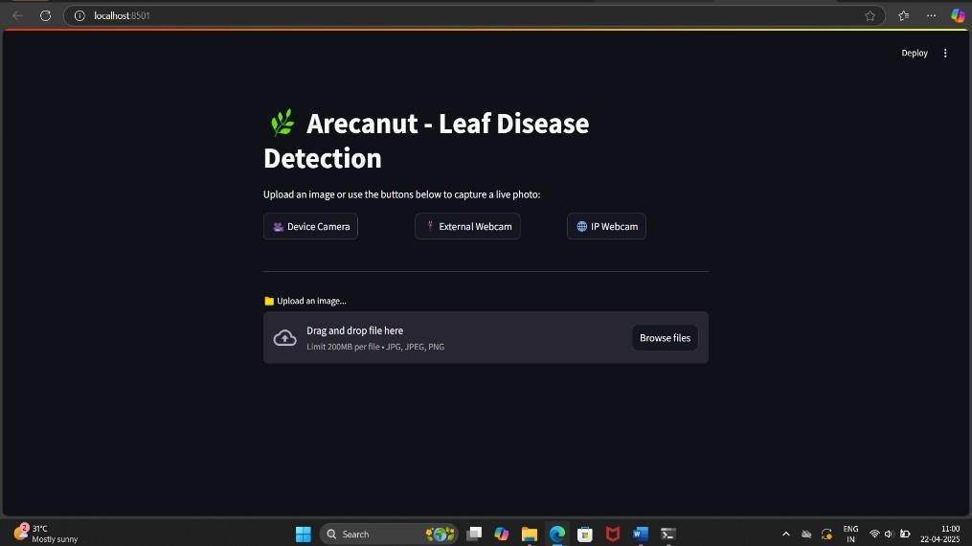
Figure 6.1 GUI Window for Arecanut-leaf disease detection

Figure 6.1 shows the Graphical User Interface (GUI) of the Arecanut Leaf Disease Detection application. The interface is designed with a dark theme, featuring a sleek and modern layout that enhances user experience. At the top, the title “Arecanut - Leaf Disease Detection” is prominently displayed with a green leaf icon, indicating the purpose of the application. Beneath it, three interactive buttons Device Camera, External Webcam, and IP Webcam allow users to capture real-time images using various camera sources. This feature makes the application flexible for both mobile and desktop use cases. Below the camera capture options, an image upload section is provided, enabling users to drag and drop or browse for image files (JPEG, JPG, PNG) with a maximum size of 200MB. This GUI is intuitive and ensures seamless interaction for farmers, researchers, or users seeking to detect
arecanut leaf diseases quickly and efficiently.

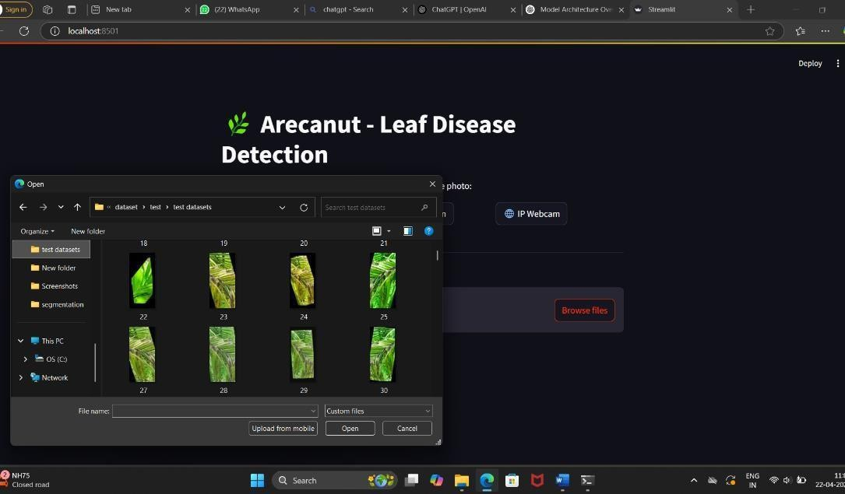
Figure 6.2 Displays a File Explore for Image upload option

Figure 6.2 shows the user-friendly file upload interface of the Arecanut Leaf Disease Detection system, which facilitates easy selection of leaf images for disease prediction. Upon clicking the “Browse files” button, a native file explorer window opens, allowing users to navigate their local storage and choose relevant images from datasets. In the screenshot, the user is accessing a folder labeled “test datasets” that contains various arecanut leaf images, each visually representing different conditions such as healthy, yellowing, or spot-affected leaves. The image thumbnails provide a quick visual reference, simplifying the selection process without the need to recall specific file names. Once an image is selected and opened, the system automatically processes it using a pre-trained deep learning model and displays the predicted disease classification on the web interface. This feature enables real-time validation of the model’s accuracy and performance using actual sample data. Additionally, the interface includes an “Upload from mobile” option, offering greater flexibility by allowing image uploads directly from mobile devices. This streamlined workflow enhances user experience, particularly for farmers or field workers who may rely on mobile-captured images. Overall, the integration of this upload feature bridges AI technology with practical usability, supporting efficient and accessible disease detection for arecanut cultivation.

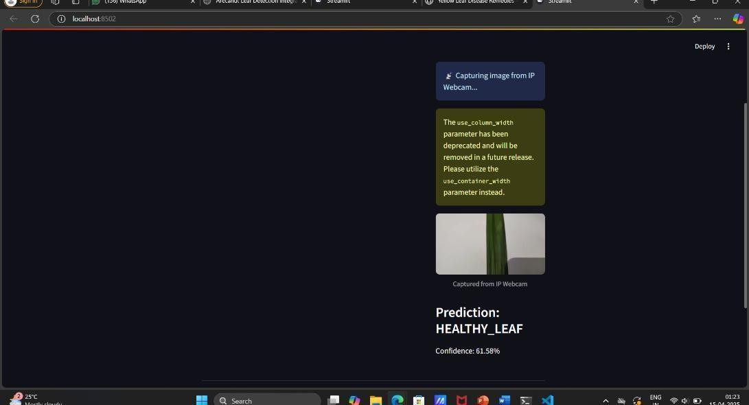

Figure 6.3 Capturing Image from IP Webcam and Prediction Display

Figure 6.3 illustrates the real-time prediction functionality of the Arecanut Leaf Disease Detection system using an IP webcam. In the screenshot, the application is actively capturing a live image feed from an external camera source, allowing users to analyze freshly captured images rather than uploading pre-stored files. Once the leaf image is captured, it is displayed below the message panel with a tag indicating it was obtained from the IP webcam. This feature adds a layer of convenience and practicality, particularly useful for field deployment where immediate diagnosis is required without the hassle of saving and uploading files. Alongside the image, the prediction result is clearly presented stating Prediction healthy leaf with a confidence score of 61.58%, signifying the model’s certainty about the classification. This transparent feedback helps users understand how confident the system is in its diagnosis. Additionally, a warning message appears on the interface regarding the deprecation of the use_column_width parameter in the underlying codebase, hinting that the application is built using the Streamlit framework. This ensures developers are aware of future compatibility changes. Overall, the integration of webcam-based input along with instant prediction and confidence display greatly enhances the application’s usability, making it a powerful tool for quick, on-site disease detection in arecanut plantations.

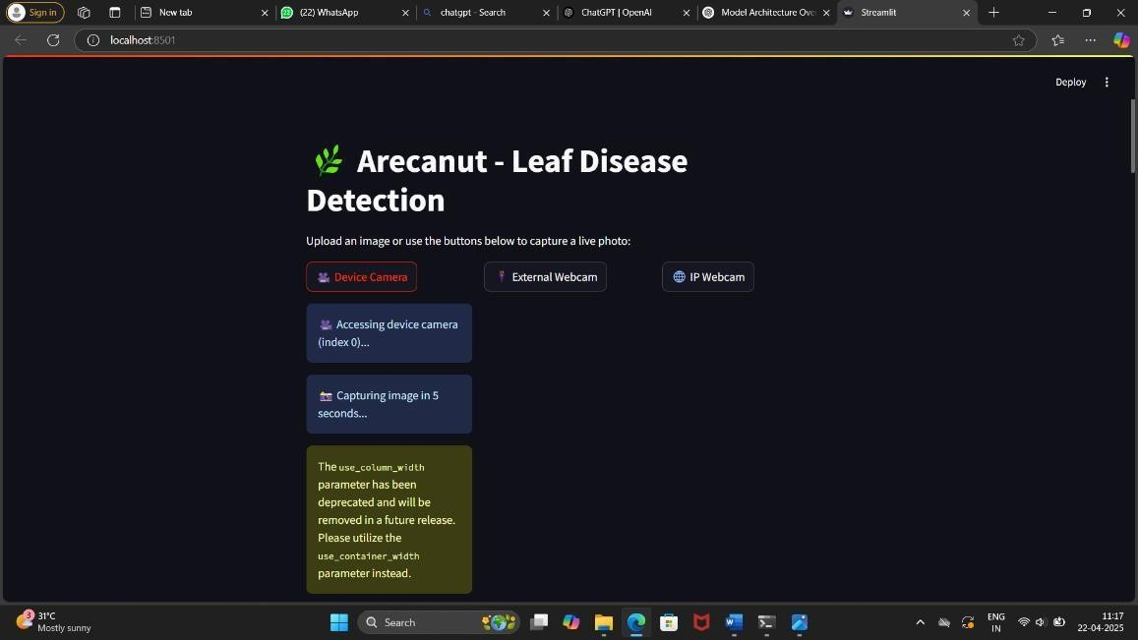
Figure 6.4 Capturing Image from IP Webcam and Prediction Display

Figure 6.4 shows the live capture functionality of the Arecanut Leaf Disease Detection application, demonstrating its ability to interface with multiple camera sources. The user interface offers three distinct options device camera, external Webcam, and IP Webcam to accommodate different hardware configurations, making the application adaptable for use in various environments. In the screenshot, the system is shown accessing the device's internal camera and initiating a five-second countdown to capture an image, providing users with a brief window to adjust the leaf placement for optimal image quality. This automated countdown improves usability, especially when operating hands-free or in field conditions. A caution message is also displayed, indicating that the use_column_width parameter in the code is deprecated and recommending the use of use_container_width instead, which is a helpful alert for developers maintaining the application. The clean and dark-themed UI ensures clarity and focus, with well-labeled buttons and informative status updates, enhancing the user experience. This functionality bridges AI with practical deployment by allowing direct image acquisition without manual uploads, making it ideal for on-the-go diagnosis. Farmers, agronomists, or researchers can capture real-time data, receive instant analysis, and make informed decisions regarding leaf health, ultimately contributing to improved arecanut crop management and disease control.

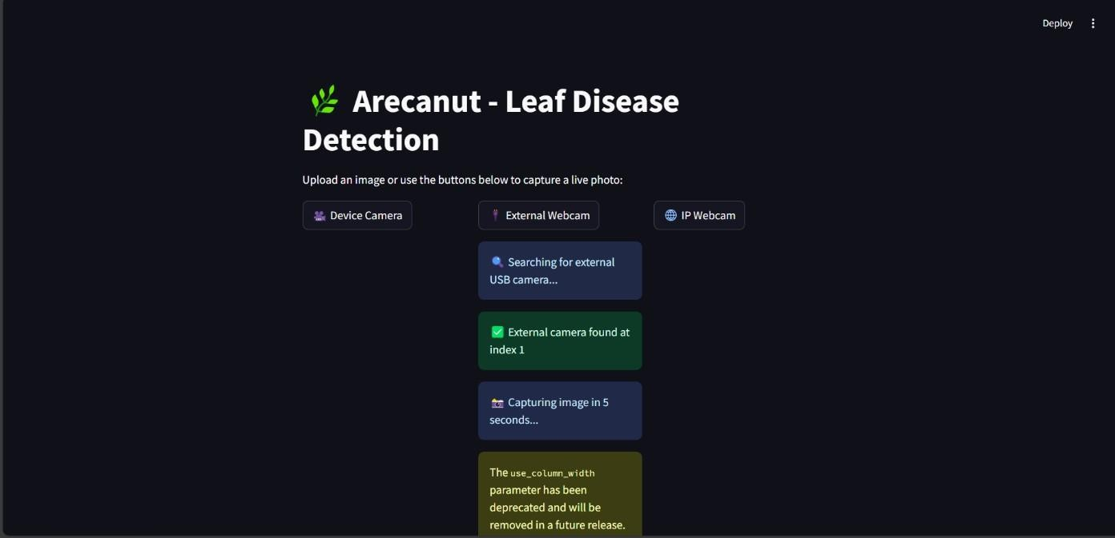
Figure 6.5 Capturing Image from External Camera and Disease Prediction

Figure 6.5 presents the seamless external webcam integration within the Arecanut Leaf Disease Detection application, showcasing its capability to interact with a variety of video input sources for real-time image capture. In the screenshot, the user has selected the external Webcam option, prompting the system to search for connected USB camera devices. Upon successful detection, the system identifies an available external camera at index 1 and prepares to capture an image, initiating a five-second countdown to allow for proper leaf positioning. This intuitive interaction ensures that users, particularly those working in agricultural fields or remote areas, can effortlessly operate the system with minimal technical expertise. Furthermore, the interface retains its consistent aesthetic, using dark backgrounds and clearly labeled interactive buttons for a visually appealing and user- friendly experience. A developer warning regarding the deprecation of the use_column_width parameter is also visible, indicating the system is built using Streamlit, and encouraging future-proofing by transitioning to the updated use_container_width. This functionality supports practical deployment in real-world scenarios, enabling users to perform disease detection directly from live camera feeds without manual uploads, enhancing efficiency and responsiveness in managing arecanut leaf health.

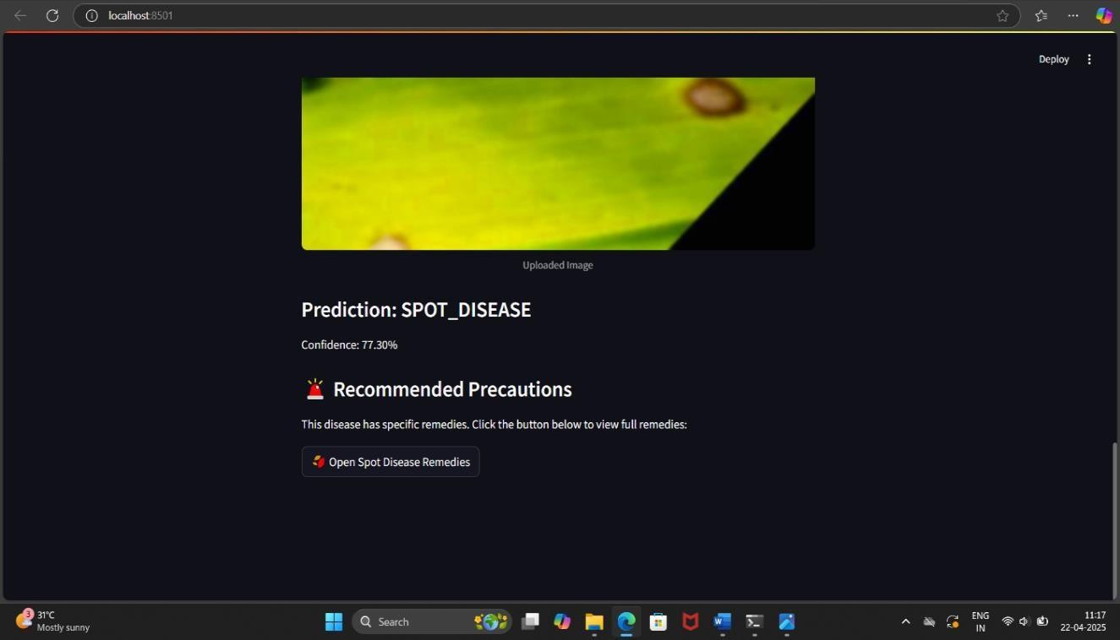
Figure 6.6 Result of Uploaded Image with Spot Disease Prediction and Remedies

Figure 6.6 illustrates the output screen of the Arecanut Leaf Disease Detection system after processing an uploaded image and identifying the presence of Spot Disease. The interface presents a clear and concise prediction result, stating “Prediction: SPOT_DISEASE” along with a confidence level of 77.30%, helping users understand the model’s certainty. Just below the prediction, the system provides valuable recommendations in the form of “Recommended Precautions,” acknowledging the seriousness of the diagnosis and guiding users toward the next steps. A prominently displayed button labeled “Open Spot Disease Remedies” encourages users to explore disease-specific treatment options, offering actionable advice to mitigate the impact. This feature significantly enhances the application's usability, transforming it from a mere diagnostic tool into a practical agricultural support system. The clean and visually engaging UI ensures that even users with limited technical knowledge can understand the results and follow through with appropriate action. The inclusion of such functionality is particularly beneficial for farmers and agricultural workers who rely on timely, accurate information to maintain crop health. By integrating both disease prediction and remedy suggestions, the system promotes a proactive approach to plant care, empowering users to make informed decisions that could improve yield and reduce losses caused by untreated leaf infections.

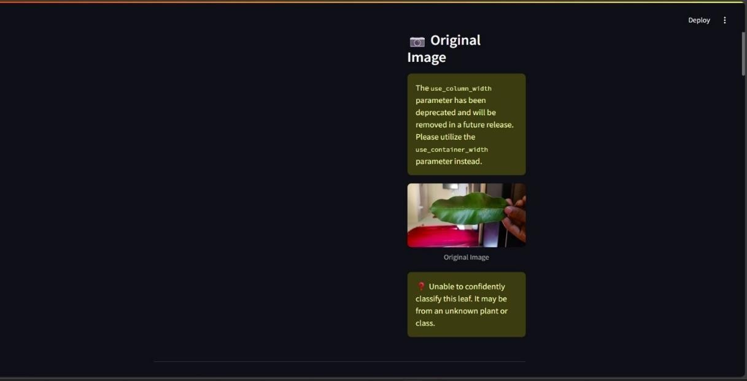
Figure 6.7 Detection of Non Arecanut Leaf

Figure 6.7 illustrates a scenario where the Arecanut Leaf Disease Detection system encounters difficulty in classifying the uploaded image. The interface presents the original image of a green leaf held by a user, alongside a clear message that reads, “Unable to confidently classify this leaf. It may be from an unknown plant or class.” This indicates that the model's training data likely did not include this specific type of leaf or the visual features were not distinct enough for reliable identification. Such feedback is essential as it maintains transparency and prevents misclassification, ensuring users do not rely on incorrect predictions. The warning is visually emphasized with a red caution icon to draw attention and suggest careful action. Additionally, a deprecated parameter warning is shown, reminding developers to update their Streamlit code for future compatibility by replacing use_column_width with use_container_width. This screen not only highlights the AI model’s current limitations but also reflects thoughtful UI design, offering clarity without overwhelming the user. It reinforces the importance of a well-trained dataset and also promotes user trust by admitting uncertainty instead of forcing a potentially incorrect result. The platform remains intuitive and user-friendly, even when outcomes are inconclusive, which adds credibility to the system's performance and reliability.

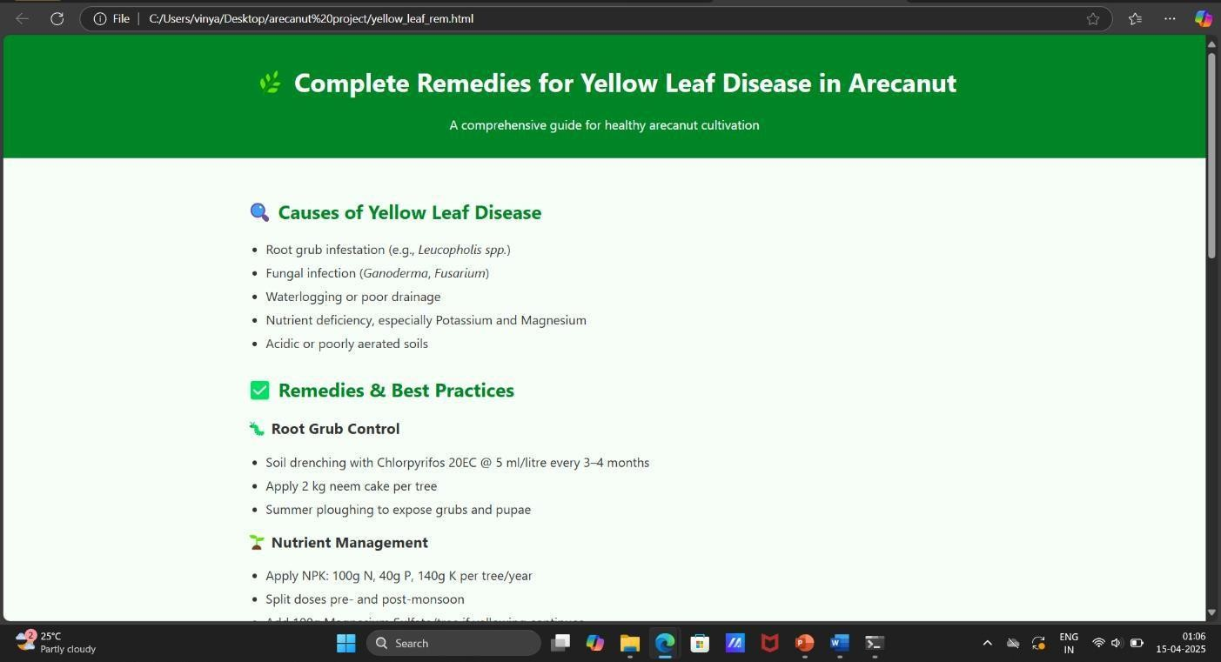
Figure 6.8 Remedies Page for Yellow Leaf Disease

Figure 6.8 presents the detailed and practical guide for managing Yellow Leaf Disease in arecanut plants, offering both causes and actionable remedies. This informative page begins by identifying the root causes such as root grub infestation (e.g., Leucopholis spp.), fungal infections like Ganoderma and Fusarium, waterlogging or inadequate drainage, and imbalanced soil nutrition, particularly deficiencies in potassium and magnesium. Additionally, it highlights that acidic or poorly aerated soils also contribute to this disease. The guide doesn’t stop at problem identification it provides clear, research-based best practices for managing the condition. Under root grub control, it recommends regular soil drenching using Chlorpyrifos 20EC every 3–4 months, applying neem cake around each tree, and conducting summer ploughing to destroy pests at the pupal stage. Nutrient management is emphasized as well, with specific instructions on applying NPK in precise quantities 100g Nitrogen, 40g Phosphorus, and 140g Potassium per tree annually, ideally in split doses around the monsoon seasons. The guidance is methodical and user-oriented, ideal for farmers seeking easy-to-follow, practical interventions. With a clean layout and accessible language, the page empowers cultivators to proactively address yellow leaf disease and maintain the growth and productivity of their arecanut plantations with confidence and clarity.
Table 6.1 Feature Values of Healthy Leaf

Feature Name | Feature Value
Low-level Feature 1 (Color) | 0.0000
Low-level Feature 2 (Texture) | 0.0353
Low-level Feature 3 (Edge Detection) | 0.0000
High-level Feature 1 (Shape) | 0.8503
High-level Feature 2 (Pattern) | 0.0022
High-level Feature 3 (Details) | 2.1922
Shape Feature 1 | 0.0000
Shape Feature 2 | 0.6531
Texture Feature 1 | 0.4471
Color Feature 1 | 0.2982

Table 6.1, the system accurately predicted the leaf to be healthy with a high confidence score of 92.56%. The feature vector shows strong values for shape (0.8503) and fine details (2.1922), while color and edge-related features remained minimal, indicating uniformity and structural integrity typical of a healthy leaf.

Table 6.2 Feature Values of Yellow Diseased Leaf
Index | Feature Name | Feature Value
0 | Low-level Feature 1 (Color) | 0.0000
1 | Low-level Feature 2 (Texture) | 0.7826
2 | Low-level Feature 3 (Edge Detection) | 0.1444
3 | High-level Feature 1 (Shape) | 0.6243
4 | High-level Feature 2 (Pattern) | 0.0000
5 | High-level Feature 3 (Details) | 0.8677
6 | Shape Feature 1 | 0.2505
7 | Shape Feature 2 | 0.5360
8 | Texture Feature 1 | 0.3982
9 | Color Feature 1 | 0.0015

Table 6.2 corresponds to a leaf exhibiting yellowing symptoms, reflected in elevated values for texture (0.7826) and detail (0.8677), though with lower edge detection (0.1444), indicating diffuse surface changes rather than defined lesions. The high texture and detail values in this case suggest early stress markers, potentially due to nutrient deficiencies. These results demonstrate the model’s ability to differentiate leaf conditions by interpreting variations in key visual features such as shape, texture, detail, and edge patterns, thereby supporting automated and accurate plant health assessment.
Table 6.3 Feature Values of Spot Diseased Leaf
Index | Feature Name | Feature Value
0 | Low-level Feature 1 (Color) | 0.0000
1 | Low-level Feature 2 (Texture) | 0.0000
2 | Low-level Feature 3 (Edge Detection) | 0.8013
3 | High-level Feature 1 (Shape) | 0.7967
4 | High-level Feature 2 (Pattern) | 0.0727
5 | High-level Feature 3 (Details) | 0.5835
6 | Shape Feature 1 | 0.0402
7 | Shape Feature 2 | 0.4907
8 | Texture Feature 1 | 1.5271
9 | Color Feature 1 | 0.0000

Table 6.3 presents a case of spot disease, where the system identified significant edge detection (0.8013) and moderate detail (0.5835), suggesting irregular patterns and localized damage on the leaf surface common characteristics of spot infections.

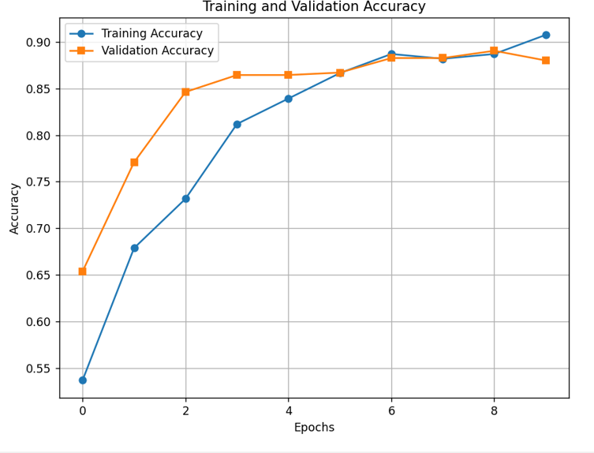
Figure 6.9 Training and Validation Accuracy Across Epochs

Figure 6.9 illustrates the progression of both training and validation accuracy for a Convolutional Neural Network (CNN) model across 10 epochs, showcasing how well the model learns and generalizes. From the graph, it is evident that training accuracy increases consistently over the epochs, starting around 54% and gradually reaching over 90% by the
end of the training cycle. Validation accuracy, on the other hand, shows a sharp rise in the early epochs, jumping from approximately 66% to around 85% within just three epochs, after which it levels off and fluctuates slightly, maintaining values close to the training accuracy. Notably, from epoch 5 onward, both training and validation accuracies remain closely aligned, suggesting the model is not overfitting and is able to generalize effectively to unseen data. The convergence of both accuracies near the 90% mark by the final epoch reflects a balanced and well-trained model. The early rapid gain in validation accuracy indicates the model quickly learned useful representations, while the later steady improvements in training accuracy suggest it continued to refine its internal parameters without compromising its ability to perform on the validation set. Overall, this performance trend reflects a healthy learning process, highlighting the robustness and reliability of the CNN architecture used.
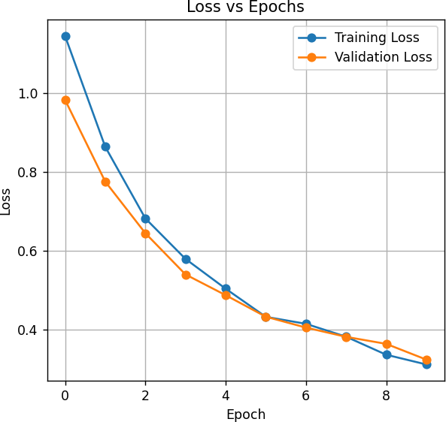

Figure 6.10 Loss VS Epochs

The Figure 6.10 illustrates the training and validation loss values over the course of 10 epochs, providing insight into the learning behavior of the CNN model. From the beginning, both losses start at relatively high levels above 1.0 for training loss and just below 1.0 for
validation loss indicating that the model initially made larger prediction errors. However, as the epochs progress, both curves exhibit a smooth and consistent downward trend, demonstrating that the model is effectively minimizing its errors during training. By epoch 5, both losses converge around 0.45, and from that point on, they continue to decline in near-parallel fashion, ending just above 0.3 by epoch 9. This close alignment between training and validation loss curves signifies a well-generalized model, as there is no significant divergence that would indicate overfitting. Steady rate of improvement across epochs suggests that the learning rate and optimization strategy were well-tuned, enabling the model to extract meaningful patterns from the data without memorizing it. Overall, the graph reflects a stable and healthy training process, reinforcing the reliability of the CNN in accurately classifying leaf diseases. The consistently low loss values towards the end also affirm that the model has achieved a strong fit on both training and validation datasets.
CHAPTER 7

CONCLUSION AND SCOPE FOR FUTURE ENHANCEMENT

Conclusion
The Arecanut Leaf Disease Detection system, built using deep learning techniques, demonstrates significant potential in accurately identifying diseases affecting arecanut leaves. By utilizing a systematic approach involving image preprocessing, feature extraction, model training and integration into a user-friendly Streamlit interface, the system effectively classifies diseases such as yellow disease. The inclusion of a dedicated arecanut leaf classifier and the ongoing integration of segmentation further enhances its performance and accuracy. However, to achieve even higher accuracy and robustness, continuous refinement and optimization are necessary, particularly in handling real-world variations in leaf images. With further advancements in the model, the system can be essential in helping farmers identify and manage diseases, thus improving crop health and yield. The project holds great promise for enhancing agricultural practices and ensuring better crop management through automated disease detection.

Scope of Future Advancement
The future advancements of the Arecanut Leaf Disease Detection system could focus on several key areas to improve its accuracy, scalability, and usability:
    - Enhanced Model Accuracy: Further improvements in the deep learning model by incorporating more advanced architectures like CNN-LSTM or attention- based models could enhance the system's accuracy in detecting diseases, even in challenging environmental conditions and diverse leaf variations.
    - Integration of Multi-Disease Detection: Expanding the system's capabilities to identify a broader range of diseases affecting arecanut leaves will increase its utility for farmers. This would involve training the model on more diverse and extensive datasets, including various stages of disease progression.
    - Real-Time Disease Detection: Implementing a real-time detection system, leveraging high-speed image processing and inference, would allow farmers to use mobile or webcam-based applications for immediate disease diagnosis in the field. This could be integrated into a mobile app for accessibility.
    - Cross-Platform Support: Developing the system to be cross-platform (web, desktop, mobile) would enable wider adoption, making the technology accessible to a larger community of farmers, researchers, and agricultural experts.
    - Segmentation and Localization: Further optimization of the segmentation module could help in accurately locating affected regions on the leaf, providing better insight for targeted treatment. Additionally, incorporating automated treatment suggestions based on the detected disease could be an essential enhancement.
    - Integration with IoT and Precision Agriculture: By integrating the system with IoT sensors or drones, real-time monitoring of the field conditions and detecting disease outbreaks in large plantations can be automated, improving the overall efficiency of disease management.
    - Improved Dataset and Real-World Adaptability: The system could be trained on more diverse datasets from various geographical regions, helping it to adapt to different environmental conditions and leaf types, thus enhancing its robustness in real-world scenarios.
By continuing to evolve these areas, the system could be essential to precision agriculture, offering an efficient, automated, and scalable method for early disease detection and management in arecanut farming.

REFERENCES

- J. G. A. Barbedo, “A review on the use of machine learning algorithms in plant disease detection,” Computers and Electronics in Agriculture, vol. 123, pp. 172–183, May 2016.
- K. P. Ferentinos, “Deep learning models for plant disease detection and diagnosis,” Computers and Electronics in Agriculture, vol. 145, pp. 311–318, Feb. 2018.
- J. Amara, B. Bouaziz, and A. Algergawy, “A deep learning-based approach for banana leaf diseases classification,” in Proceedings of the BTW Workshops, pp. 79– 88, March 2017.
- S. Sladojevic, M. Arsenovic, A. Anderla, D. Culibrk, and D. Stefanovic, “Deep neural networks based recognition of plant diseases by leaf image classification,” Computational Intelligence and Neuroscience, vol. 2016, pp. 1–11, Jan. 2016.
- S. P. Mohanty, D. P. Hughes, and M. Salathé, “Using deep learning for image-based plant disease detection,” Frontiers in Plant Science, vol. 7, art. no. 1419, Sept. 2016.
- S. S. Chouhan, A. Kaul, U. P. Singh, and S. Jain, “A novel approach for plant leaf disease classification using deep learning,” Information Processing in Agriculture, vol. 7, no. 4, pp. 535–545, Dec. 2020.
- M. Brahimi, K. Boukhalfa, and A. Moussaoui, “Deep learning for tomato diseases: Classification and symptoms visualization,” Applied Artificial Intelligence, vol. 31, no. 4, pp. 299–315, Apr. 2017.
- C. Szegedy et al., “Going deeper with convolutions,” in Proceedings of the IEEE Conference on Computer Vision and Pattern Recognition, pp. 1–9, June 2015.
- D. Ravi et al., “Deep learning for health informatics,” IEEE Journal of Biomedical and Health Informatics, vol. 21, no. 1, pp. 4–17, Jan. 2017.
- N. Pathak and R. Mathur, “A hybrid approach for plant disease detection using CNN and Decision Trees,” Journal of Ambient Intelligence and Humanized Computing, vol. 12, no. 6, pp. 6535–6545, June 2021.
- S. Ghosal et al., “An explainable deep machine vision framework for plant stress phenotyping,” Proceedings of the National Academy of Sciences, vol. 115, no. 18,
pp. 4613–4618, May 2018.
- C. Nicolas, L. Tissot, and S. Dupont, “A convolutional neural network-based approach for real-time plant disease detection,” Procedia Computer Science, vol. 159,
pp. 2145–2152, Dec. 2019.
- S. Sankaran, A. Mishra, R. Ehsani, and C. Davis, “A review of advanced techniques for detecting plant diseases,” Computers and Electronics in Agriculture, vol. 72, no. 1, pp. 1–13, Mar. 2010.
- M. Shoaib, M. J. Khan, S. Khan, and A. Shaukat, “A comprehensive review of deep learning in plant disease detection,” Artificial Intelligence Review, vol. 55, no. 3, pp. 2691–2738, Mar. 2022.
- K. SandhyaRani and M. Shyamala, “Deep learning applications in Indian agriculture: A survey,” International Journal of Computer Applications, vol. 183, no. 47, pp. 15– 20, Nov. 2021.
- A. Rehana and K. Ashok, “Leaf disease detection using region-based convolutional neural networks,” Journal of Agricultural Informatics, vol. 11, no. 2, pp. 23–31, Dec. 2020.
- A. Mustofa and S. Nandhini, “CNN-based plant leaf disease classification: A review,” Materials Today: Proceedings, vol. 45, pp. 6670–6676, May 2021.
- M. Karuna and S. Lavanya, “GUI-based tomato leaf disease classification using deep learning,” International Journal of Scientific Research in Computer Science, Engineering and Information Technology, vol. 8, no. 2, pp. 12–19, Feb. 2022.
- R. Gohil, D. Shah, and A. Patel, “Real-time plant leaf disease detection using CNN and YOLOv5,” Procedia Computer Science, vol. 218, pp. 451–458, Dec. 2023.
- M. Ramesh and K. Suresh, “A mobile-based plant disease detection system using CNN,” Journal of Mobile Computing and Application, vol. 8, no. 1, pp. 34–41, Jan. 2022.
- M. Zhang, Q. Wu, Z. Li, and Y. Wang, “Transfer learning for automatic detection of crop diseases,” IEEE Access, vol. 12, pp. 35601–35610, Apr. 2024.
- O. Terrada, F. B. Hmida, and D. Bouslimi, “Classification and prediction of atherosclerosis diseases using machine learning algorithms,” Healthcare Analytics, vol. 3, art. no. 100164, Jan. 2023.
- I. Pacal, E. Karaman, and A. Uçar, “Plant leaf disease classification using EfficientNet and Vision Transformers,” Computers and Electronics in Agriculture, vol. 191, art. no. 106553, Oct. 2021.
- S. Selim, A. El-Sayed, and A. Salem, “Explainable AI for plant disease classification using saliency maps,” Journal of Computer Science and Technology, vol. 36, no. 5,
pp. 905–918, Sept. 2021.
- M. H. Saleem, J. Potgieter, and K. M. Arif, “Plant disease detection and classification by deep learning: A review,” Plant Methods, vol. 17, no. 1, art. no. 22, Jan. 2021

